**1. Identification of the substance/ mixture and of the company/ undertaking**

**1.1. Product identifier**

Trade name : TLNH-204

Chemical Name : : Mixture of surfactants.

**1.2. Recommended use of the chemical and restrictions on use**

Recommended use : Textile auxiliary.

Non-recommended : none known.

**1.3. Details of the supplier of the safety data sheet**

Company : HUNG XUONG CHEMICAL CO., LTD.

Telephone : +84 272 377 8055/56

Telefax : +84 272 377 80

E-mail : info@hungxuong.com

**1.4. Emergency telephone number**

Emergency : +84 272 377 8055

Information :

**2. Hazards identification**

**2.1. Classification of the substance or mixture**

**GHS Classification and classification according to Regulation on classification and labeling of chemicals - Number 04/2012/TT-BCT.**

Skin corrosion/irritation Category 3

Serious eye damage/eye irritation Category 2

Aquatic Acute Category 1

**2.2. Label elements**

**GHS Label elements** 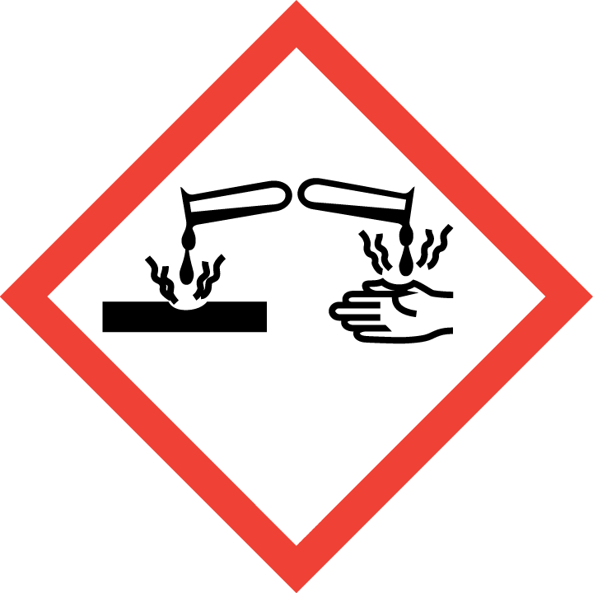

Hazard pictograms :



Signal word : DANGER

Hazard statement :

H316:Causes mild skin irritation.

H319:Causes serious eye irritation.

H401 : Toxic to aquatic life

Precautionary statement:

Prevention :

P280- Wear protective gloves/protective clothing/eye protection/face protection.

Response:

P-273-Avoid release to the environment.

P305+P351+P338- IF IN EYES Rinse cautiously with water for several minutes. Remove contact lenses, if present and easy to do. Continue rinsing.

P332+P313:If skin irritation occurs, get medical advice/attention

P308 + P310 IF exposed or concerned: immediately call a POISON CENTER or doctor/ physician

Storage :

No special measures required.

Disposal :

P501- Disposal of contents / container in accordance with national

regulations.

**2.3. Other hazards**

None known

**3. Composition/information on ingredients**

**3.1. Substance**

**-**

**3.2. Mixture**

Information on ingredients / Hazardous components

|  |  |  |  |
| --- | --- | --- | --- |
| Chemical Name | CAS-No | Concentration (%) | Classification GHS |
| Polyoxyethylene Lauryl Ether | 9002-92-0 | 2 | Acute toxicity-Oral 5, H-303 |
| Sodium Dodecyl Benzene Sulfonate 80PCT |  | 2.56 | Skin corrosion/irritation 2, H-315.  Serious eye damage/eye irritation 3, H-320 |
| Urea | 57-13-6 | 3.0 |  |
| Polyoxyethylene C12C14 ether | 68439-50-9 | 3 | Acute toxicity-Oral 5, H-303  Skin corrosion/irritation 3, H-316  Serious eye damage/eye irritation 2A, H-319 |
| (C10-C16) Alkyl alcohol ethoxylate | 68002-97-1 | 1.16 | Skin corrosion/irritation 2, H-315.  Serious eye damage/eye irritation 3, H-320 |
| ABLUTEX D-600 |  | 5.5 | Skin Irrit. 2; H315  Eye Irrit.2; H319  Aquatic Chronic 3; H412 |
| Isopropyl alcohol | 67-63-0 | 2.5 | Skin corrosion/irritation 2, H-315.  Serious eye damage/eye irritation 3, H-320 |

**4. First aid measures**

**4.1. Description of first aid measures**

General advice : If medical advice is needed, provide SDS document to physician.

Inhalation : Remove the victim from exposure or move to well- ventilated area.

If there is difficulty in breathing, medical advice is required.

Skin contact : After contact with skin, wash with plenty of soap and water.

Remove contaminated clothing, shoes and leather accessories.

Eye contact : Rinse cautiously with water for several minutes. Remove contact lenses, if present and easy to do. Continue rinsing. If eye irritation persist –Get medical advice/ attention .

Ingestion : In case of swallowing, rinse mouth, drink plenty of water. If feel unwell, seek medical advice.

**4.2. Most important symptoms and effects, both acute and delayed**

Delayed/Immediate effects: Long-term inhalation of excessive dust may cause delayed

lung injury.

**4.3. Indication of any immediate medical attention and special treatment needed**

Treat symptomatically

Immediate/Special Treatment: Eye wash stations should be available

**5. Fire-fighting measures**

**5.1. Extinguishing media**

Suitable extinguishing media : fine water spray, foam, dry powder, CO 2

**5.2. Special hazards arising from the substance or mixture**

In the event of fire the following can be released: carbon monoxide, carbon dioxide, sulphur oxides

**5.3. Advice for firefighters**

On burning, fire fighter should wear self-contained breathing apparatus if risk of exposure to

product of combustion.

**6. Accidental release measures**

**6.1. Personal precautions, protective equipment and emergency procedures**

Use personal protective equipment. Do not touch or walk through spilled material.

Do not create dust.

**6.2. Environmental precautions**

Take up and fill into a closable container. Prevent run off into drains and waterways.

Keep away from heat. Keep away from sources of ignition. Stop leak if without risk.

**6.3. Methods and material for containment and cleaning up**

Clean-Up Procedures: Collect as much as possible for use or disposal in a properly labeled container. Flush remainder into normal drainage with copious amounts of water.

**7. Handling and storage**

**7.1. Precautions for safe handling**

Advice on safe : wear protective equipment when working. Ensure there is

handling sufficient ventilation in the area. Avoid generating dust.

Hygiene measures : Do not eat, drink or smoke when working. Wash hands before

breaks and after work.

General protective : Do not inhale gases/ vapours/ aerosols. Avoid contact with eyes and

measures skin.

**7.2. Condition for safe storage, including any incompatibilities**

**Prevention of fire and explosion**

Information : no special measures required.

**Storage**

Information : none

Further Information on storage conditions:

Keep container tightly closed and store in a cool, dry well- ventilated location.Store away from heat, flames, ignition sources and incompatibles, keep away from direct sunlight. Avoid contact with water and humidity. . Check regularly for leaks. Store locked up.

**8. Exposure controls / Personal protection**

**8.1. Control parameters**

Exposure limit(s)

-

**8.2. Exposure controls**

Appropriate : operate in well- ventilated area.

engineering controls

Personal protective equipment

Eye protection : wear safety goggles.

Hand protection : protective gloves.

Body protection : protective working clothes and safety shoes.

Respiratory : wear respirator

protection

**9. Physical and chemical properties**

**9.1. Information on basic physical and chemical properties**

Physical state or appearance: liquid

Color : colorless.

Odor : Mild

Odor Threshold : no data available.

pH of 1% liquid (25°c) : 6.0-8.0.

Melting point : no data available.

Boiling point : no data available.

Flash point : no data available

Evaporation rate : no data available.

Flammability : no data available.

Upper Explosion/Ignition limit: no data available.

Lower explosion limit : no data available.

Vapour pressure : no data available.

Relative vapuor : no data available.

Relative density : no data available.

Solubility : soluble in water.

Partition coefficient : no data available.

(n-octanol/water)

Autoignition : no data available.

temperature

Thermal : no data available.

decomposition

Viscosity, kinematic : no data available.

Viscosity, Dynamic : no data available.

Oxidizing properties : no data available.

**9.2. Other Information**

Density : no data available

Metal corrosion : no data available.

**10. Stability and reactivity**

**10.1. Reactivity**

Stable in normal room temperature.

**10.2. Chemical stability**

The product is stable under normal conditions.

**10.3. Possibility of hazardous reactions**

Reacts violently with hydrogen + palladium combination, nitroform, oleum, COCl2, aluminum triisopropoxide, oxidants Incompatible with acetaldehyde, chlorine, ethylene oxide, isocyanates, acids, alkaline earth, alkali metals, caustics, amines, crotonaldehyde, phosgene, ammonia. Isopropyl alcohol reacts with metallic aluminum at high temperatures. Isopropyl alcohol attacks some plastics, rubber, and coatings. Vigorous reaction with sodium dichromate + sulfuric acid

**10.4 Conditions to avoid**

Conditions to Avoid: Avoid high temperatures and fire

**10.5. Incompatible materials**

Avoid contact with strong acids and oxidizing agents

**10.6 Hazardous decomposition products**

No dangerous decomposition products known.

**11. Toxicological information**

**11.1. Information on toxicological effects**

Acute toxicity (oral) : not classified

Acute toxicity (inhalation) :not classified

Acute toxicity (dermal) : not classified.

Irritation/corrosion : Causes mild skin irritation.

of the skin

Serious eye damage/ : Causes serious eye damage.

eye irritation

Repeated dose toxicity : not classified.

**CMR assessment**

Carcinogenicity : not classified.

Mutagenicity : not classified.

Teratogenicity : not classified.

Toxicity to reproduction: not classified.

Specific Target Organ : not classified.

Toxicity-single exposure

Specific Target Organ : not classified.

Toxicity-Repeated exposure

Aspiration hazard : not classified.

**12. Ecological information**

**Ecotoxicology Assessment**

No data available.

**12.1. Ecotoxicity**

No data available.

**12.2. Persistence and degradability**

No data available

**12.3. Bioaccumulative potential**

No data available.

**12.4. Mobility in soil**

. No data available

**12.5. Other adverse effects**

Discharge into the environment must be avoided

**13. Disposal considerations**

**13.1 Waste treatment methods**

Waste from residue: Disposal should be in accordance with local regulations and legislation.

Contaminated packaging: Dispose of empty contaminated containers in accordance with

regulations and legislation.

**14. Transport information**

Not classified as dangerous goods for transport

**D.O.T Road/Rail**

UN number : not applicable.

UN proper shipping name: not applicable.

Hazard label: not applicable.

Transport hazard class (es): not applicable.

. Packing group : not applicable.

Transport in bulk : not applicable.

. Special precaution for user: not applicable.

**Air transport ICAO-TI/IATA-DGR**

. UN number : not applicable.

UN proper shipping name: not applicable.

Transport hazard class(es): not applicable.

Packing group : not applicable.

Transport in bulk : not applicable.

. Special precaution for user: not applicable.

**Sea transport IMDG**

UN number : not applicable.

UN proper shipping name: not applicable.

Hazard label: not applicable.

Transport hazard class(es): not applicable.

Packing group : not applicable.

Environmental hazards (Marine pollutant): yes

Transport in bulk : not applicable.

Special precaution for user: not applicable.

**15. Regulatory information**

**15.1 Safety, health and environmental regulations/ legislation specific for the**

**substance or mixture.**

* Regulation on classification and labeling of chemicals - Number 04/2012/TT-BCT - Date issued :13/02/2012
* Regulations on the list of hazardous industrial goods to be packed in the process of transporting and transporting dangerous industrial goods by road, rail and inland waterway transport - number: 44/2012/TT-BCT - Date issued 28/12/2012
* National technical standard for ambient air quality - QCVN05:2013/BTNMT
* National technical regulation on some hazardous substances in the surrounding air - QCVN06:2009/BTNMT
* Decision, No.3733/2002/QD-BYT.

**16. Other information**

The information in the sheet were written based on the best knowledge and experience

currently available but without liability.

SDS prepared on: December 29, 2020

Revision date :December 31, 2020

Version 1.0

Legend

TWA: Time Weighted Average.

STEL: Short term exposure limit.

IATA: International Air Transport Association

ICAO: International Civil Aviation Organization

IMDG: International Maritime Dangerous Goods

Acute Toxicity-Oral.5: Acute toxicity oral, hazard category 5

Skin Irrit.2: Skin irritation, hazard category 3

Eye Irrit.2A: eye irritation, hazard category 2

Aquatic Acute 1: Aquatic Acute, hazard category 1

H303- May be harmful if swallowed.

H316:Causes mild skin irritation.

H319:Causes serious eye irritation.

H401 : Toxic to aquatic life